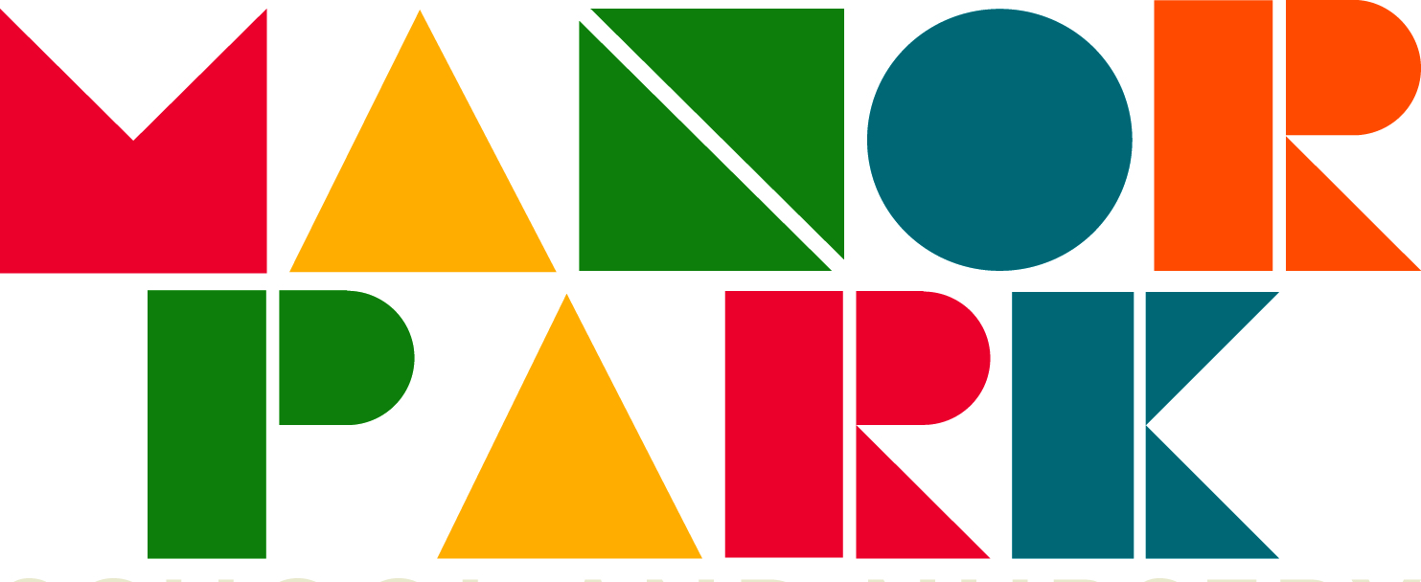
Questions to help you get more from your child’s reading book

Book introduction  Who is the author?  What can you see on the front cover?  What do you think this book is going to be about?  Does the blurb (on the back cover) give us any more clues?  Who do you think the characters are going to be like? | Understanding what you have read  What do you think is happening here?  What happened in the story?  What might this mean?  Which part of the story best describes the…?  Which words or phrases do this?  What part of the story do you like the best? | Recalling information from the book  Where does the story take place?  What did he/she/it look like?  Who was he/she/it?  Where did he/she/it live?  Who are the characters in the book?
Giving reasons  What makes you think that?  How do you feel about ….?  Can you explain why ……?  I wonder why the author...?  Which words has the author used to show that this character is funny / naughty / mean / kind? | Discussing the story  Could this book be better?  Is it as good as ….?  Which did you prefer? Why?  Who was your favourite character?  Which was your favourite part of the story?

