Kelsall Connected Curriculum

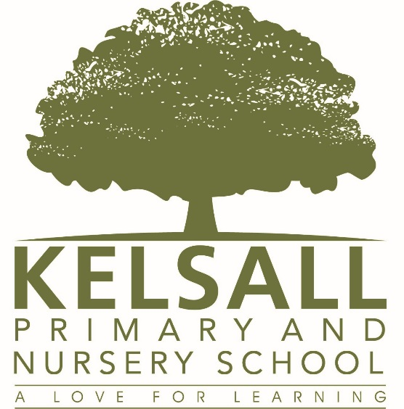
‘A Love for Learning’
Kelsall Primary & Nursery School
Writing Overview
Kelsall Connected Curriculum
The curriculum at Kelsall Primary School developed over a number of years is firmly rooted in and stems directly from our Vision, Mission and Core Values;
Our Vision – ‘A Love for Learning’
Our Mission – ‘To inspire the highest quality learning in a creative, collaborative environment’
Our Core Values – Creativity, Excellence, Curiosity, Aspiration & Respect
Intent
As children move to secondary education, we want them to leave with ‘A Love for Learning’ and a motivating desire to develop as a learner, finding out more about the World they live in and the boundless opportunities that are all around them.
Implementation
At Kelsall, our Connected Curriculum is planned around the development of Knowledge, Skills and Understanding. Our teachers have the freedom to develop innovative and effective approaches to teaching in order to create a curriculum that is tailored to their class and the children's very specific needs. We ensure a curriculum that nurtures fascination and imagination and promotes an appreciation of creativity & individuality. One that also works in strong partnership with parents and carers to ensure high standards, engendering a strong sense of community, where all children and families are key to the delivery of a challenging, inspirational and innovative curriculum. Core knowledge and skills are at the heart of the learning process with the children exploring a wide range of topics, to prepare them for life. There is a strong focus on English, Maths and IT. This includes emphasis on encouraging children to develop their spoken English well and to apply their skills to everyday life.
As a school we encourage personal development – to help children grow up happy and healthy. This develops children’s confidence, enhancing their ability to learn, and helping them to grow up to become responsible adults.
Impact
The impact of our connected curriculum is evident through the monitoring and evaluation cycle, where leaders, in particular subject leads take a holistic view. They reflect on current practice and seek to develop innovative and creative approaches to further enhance the curriculum offer for all children.

At Kelsall Primary & Nursery School we understand the importance of the written word and its role in inspiring children and unlocking their potential across the curriculum. Children who love the written word unlock a whole world of inspiration which can then translate into progression, achievement and passion in other areas.
We teach writing following the Pathways to Write units of work. These units of work are written by experienced English consultants and our teachers adapt these for bespoke delivery to their classes based on each year group's individual needs.
The units of work ensure children cover the National Curriculum for English in its entirety for writing; and the progressive structure of the programme ensures children's learning develops through the introduction of new skills being taught and regular opportunities to revisit and develop existing skills.
Pathways to Write is a proven methodology built around units of work which develop vocabulary, reading and writing skills through the mastery approach. The units, for use with pupils from EYFS to Y6, provide clear detailed lesson plans and resources, linked to high-quality texts to ensure engaging and purposeful English lessons. Effective teaching strategies to challenge greater depth writers are included within each unit of work.
The whole school package includes 42 full units of work, six for each year group from EYFS to Year 6. Further documents within the package to support the effective implementation of Pathways to Write include: an overview of year group skills from EYFS to Y6, a document to guide the progression and tracking of skills, an overview of reading and spoken language and a progressive guide to genres. Plus, writing opportunities for the application of grammar and punctuation.
Within each unit, there are new age-related skills for children to work on and master through a variety of activities and writing opportunities. By limiting the number of skills the units contain, children can really hone their writing techniques, providing an excellent, focussed assessment opportunities for teachers.
At regular intervals, there are suggestions for extending greater depth writers within the context of the lesson. These are simple, manageable and effective with little additional planning required.

Key elements of Pathways to Write:
Six detailed units of work for each year group from EYFS to Year 6
PowerPoints for each unit Y1-Y6 to support the delivery of the planning
Fully resourced sessions inspired by engaging texts
Progressive development vocabulary, reading and writing skills through the mastery approach
Links creatively to the wider curriculum
Challenges greater depth writers
Full coverage of grammar and punctuation for each year group
Suggested whole class read to compliment the main units
3-4 weeks of planning gives schools and teachers time to incorporate other themes and topics into the curriculum
The texts our teachers use to deliver our English curriculum can be seen below;

Year 1 | Autumn 1 | Autumn 2 | Spring 1 | Spring 2 | Summer 1 | Summer 2
 | 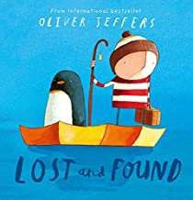 | 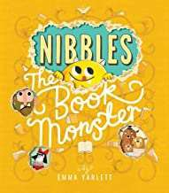 | 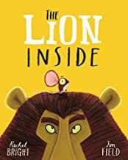 | 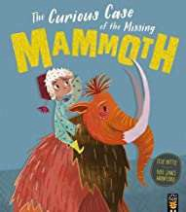 | 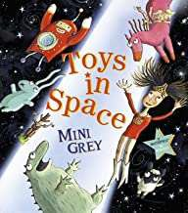 | 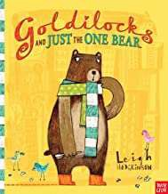
 | Focus: Fiction, adventure story | Focus: Recount, diary | Focus: Fiction, journey story | Focus: Fiction, adventure story | Focus: Fiction, fantasy story | Focus: Fiction, traditional story

Year 2 | Autumn 1 | Autumn 2 | Spring 1 | Spring 2 | Summer 1 | Summer 2
 | 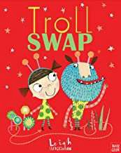 | 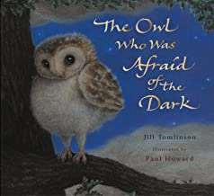 | 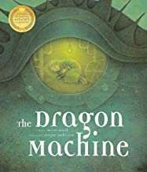 | 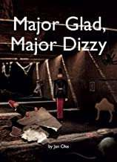 | 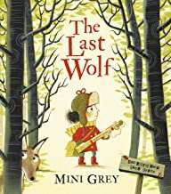 | 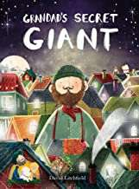
 | Focus: Fiction, character focus | Focus: Non chronological reports | Focus: Fiction, adventure focus | Focus: Recount, diary entry | Focus: Letters, writing in role | Focus: Fiction, moral focus

Year 3 | Autumn 1 | Autumn 2 | Spring 1 | Spring 2 | Summer 1 | Summer 2
 | 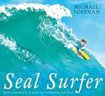 | 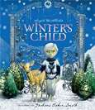 | 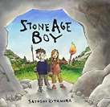 | 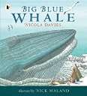 | 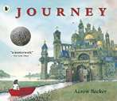 | 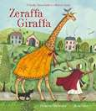
 | Focus: Recounts, letters in role | Focus: Fiction, fantasy story | Focus: Historical narratives | Focus: Information persuasion text | Focus: Fiction, adventure story | Focus: Persuasion, information text

Year 4 | Autumn 1 | Autumn 2 | Spring 1 | Spring 2 | Summer 1 | Summer 2
 | 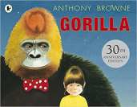 | 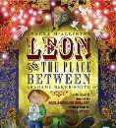 | 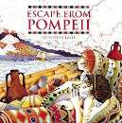 | 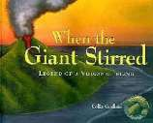 | 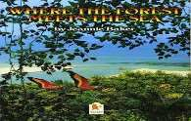 | 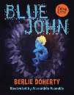
 | Focus: Fantasy story | Focus: Recounts, diary writing | Focus: Historical narratives | Focus: Adventure story | Focus: Non chronological report | Focus: Explanation texts, writing in role

Year 5 | Autumn 1 | Autumn 2 | Spring 1 | Spring 2 | Summer 1 | Summer 2
 | 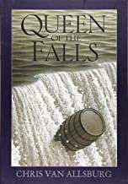 | 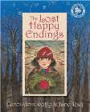 | 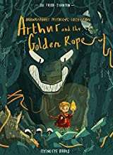 | 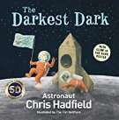 | 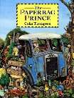 | 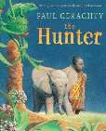
 | Focus: Recounts, diary entries | Focus: Traditional tales | Focus: Myths and legends | Focus: Recounts, biographies | Focus: Persuasion, information text | Focus: Information text

Year 6 | Autumn 1 | Autumn 2 | Spring 1 | Spring 2 | Summer 1 | Summer 2
 | 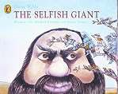 | 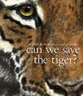 | 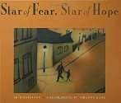 | 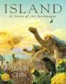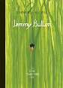 | 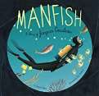 | 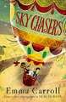
 | Focus: Narrative retelling of Selfish giant | Focus: Hybrid text (information, explanation, persuasion) | Focus: Flashback story | Focus: Journalistic (hybrid) report about Charles Darwin | Focus: Multi-modal biography of Jaques Cousteau | Focus: Write the next chapter

‘A Love for Writing’

