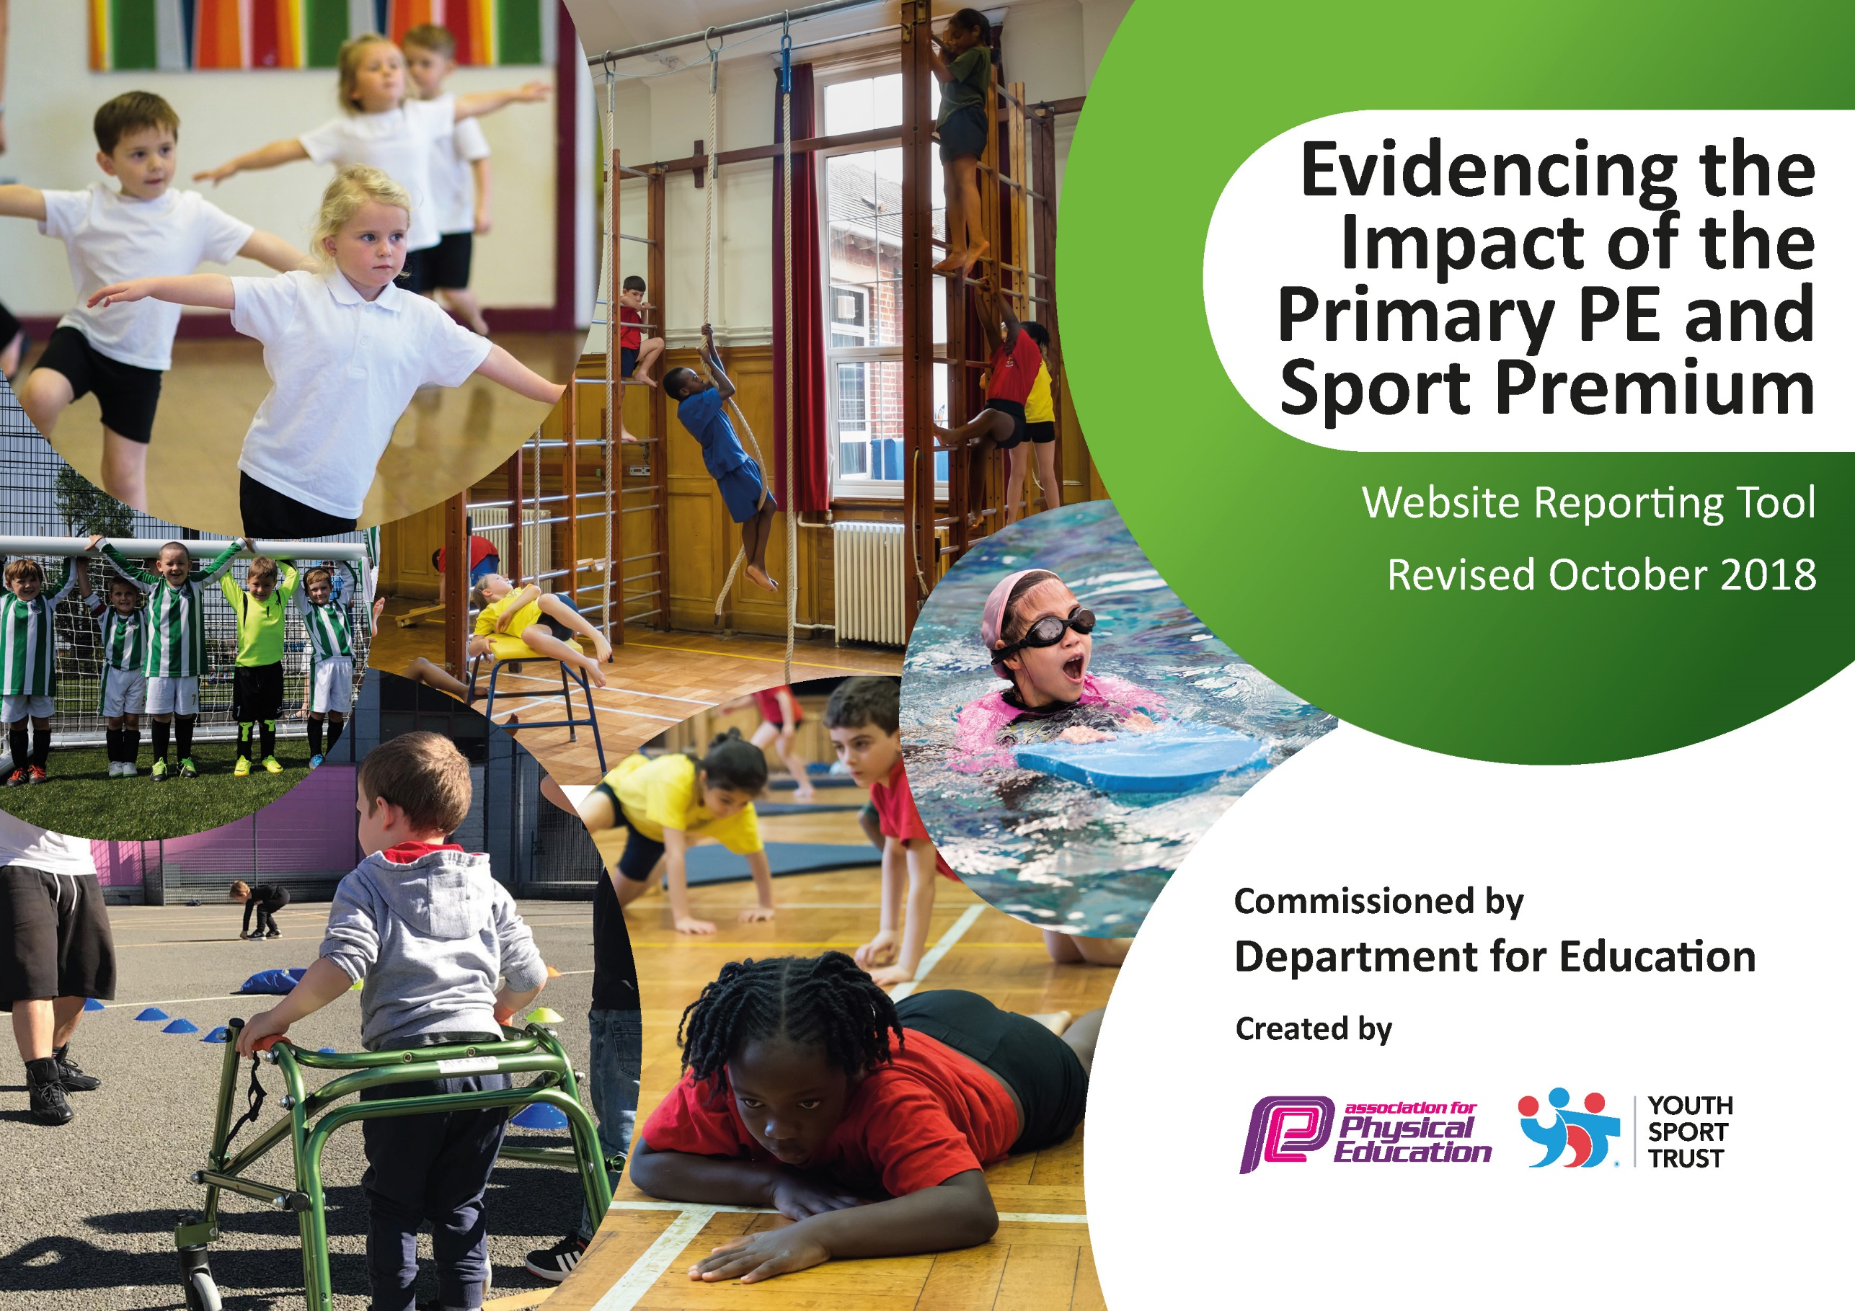
2019-2020
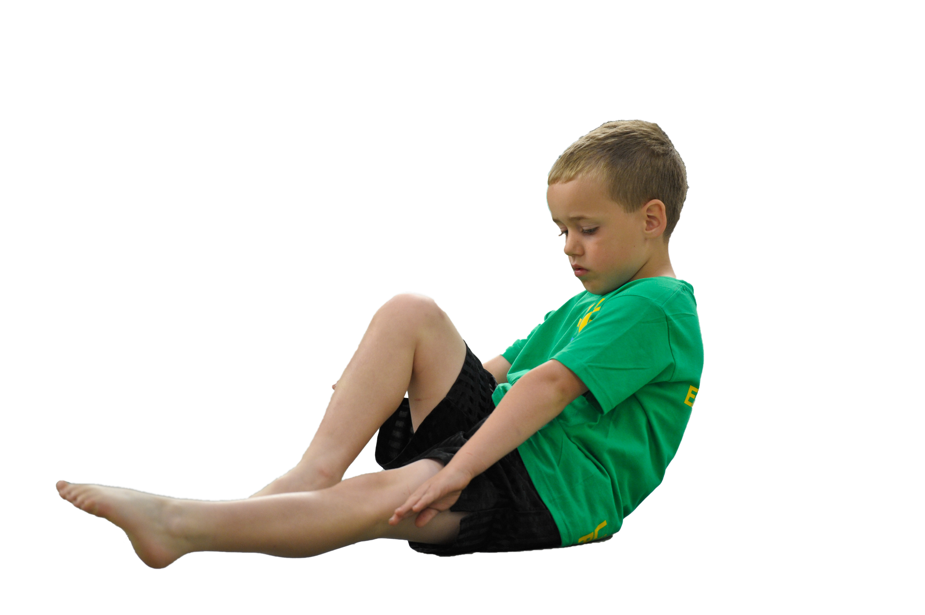
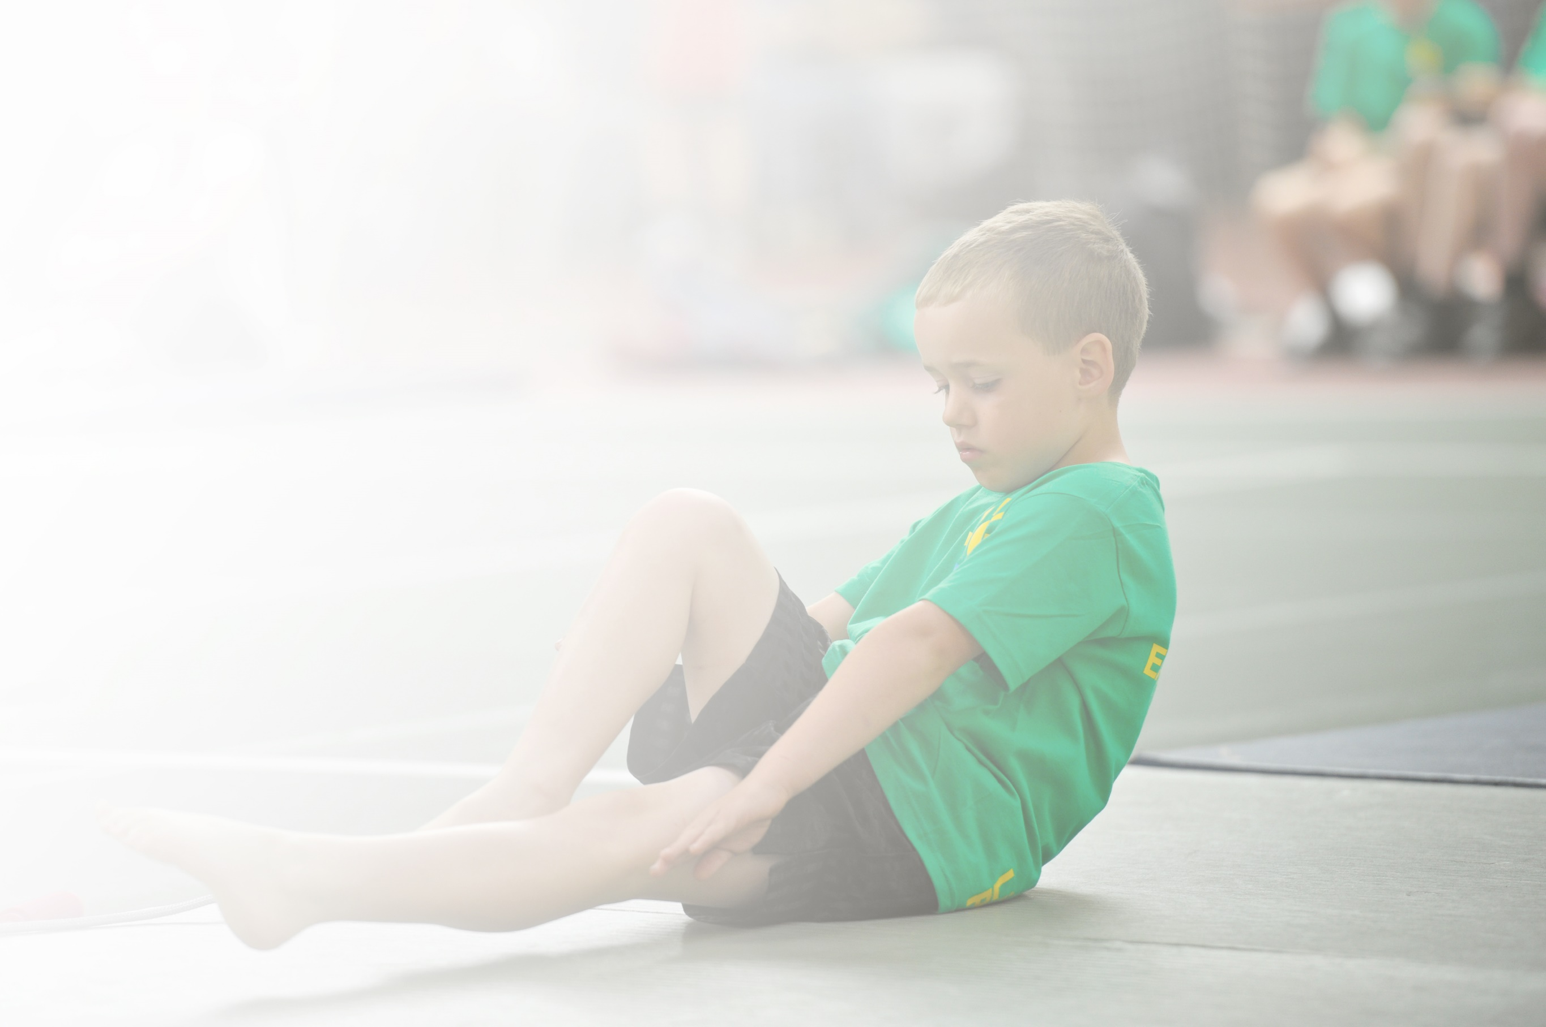
Schools must use the funding to make additional and sustainable improvements to the quality of Physical Education, Sport and Physical Activity (PESPA) they offer. This means that you should use the Primary PE and Sport Premium to:

- Develop or add to the PESPA activities that your school already offer
- Build capacity and capability within the school to ensure that improvements made now will benefit pupils joining the school in future years

Please visit gov.uk for the revised DfE guidance including the 5 key indicators across which schools should demonstrate an improvement. This document will help you to review your provision and to report
your spend. DfE encourages schools to use this template as an effective way of meeting the reporting requirements of the Primary PE and Sport Premium.

We recommend you start by reflecting on the impact of current provision and reviewing the previous
spend. Under the Ofsted Schools Inspection Framework, inspectors will assess how effectively leaders use the Primary PE and Sport Premium and measure its impact on outcomes for pupils, and how effectively governors hold them to account for this.

Schools are required to publish details of how they spend this funding as well as on the impact it has on pupils’ PE and sport participation and attainment by the end of the summer term or by 31 July 2019 at the
latest.
We recommend regularly updating the table and publishing it
on your website throughout the year, as evidence of your
ongoing review into how you are using the money to
secure maximum, sustainable impact. To see an
example of how to complete the table please
click HERE.

Kelsall Primary and Nursery School –
Primary PE and Sports Premium Review and Plan 2019-20

Key achievements to date: | Areas for further improvement and baseline evidence of need:
The development of the daily mile track around the playground has encouraged children to be active at break times and lunchtimes, as well as being used more widely for before and after school clubs (running).  Last year, the vast majority of the Sports Premium was allocated to developing the EYFS outdoor area. This was seen as a key development to ensure that the important physical and social aspects of learning were supported for our 2,3,4 and 5 year old children. The legacy of the engaging outdoor area will ensure that physical activity is at the forefront of early education for all children joining the Kelsall learning community. | Further professional development for all staff to ensure that T&L in PE and Sports is up to date and based on recent research.  Further development of playground areas to support PE and Sports, including the purchase of additional equipment and storage facilities.  Development of outdoor areas to encourage physical activity at playtimes.

Meeting national curriculum requirements for swimming and water safety | Please complete all of the below:
What percentage of your current Year 6 cohort swim competently, confidently and proficiently over a distance of at least 25 metres?  N.B. Even though your children may swim in another year please report on their attainment on leaving  primary school. | %
What percentage of your current Year 6 cohort use a range of strokes effectively [for example, front crawl, backstroke and breaststroke]? | %
What percentage of your current Year 6 cohort perform safe self-rescue in different water-based situations? | %
Schools can choose to use the Primary PE and Sport Premium to provide additional provision for swimming but this must be for activity over and above the national curriculum requirements. Have you used it in this way? | No

Action Plan and Budget Tracking
Capture your intended annual spend against the 5 key indicators. Clarify the success criteria and evidence of impact that you intend to measure to evaluate for students today and for the future.

Academic Year: 2019/20 | Total fund allocated: £8000 | Date Updated: October 2019
Key indicator 1: The engagement of all pupils in regular physical activity – Chief Medical Officer guidelines recommend that primary school children undertake at least 30 minutes of physical activity a day in school |  |  |  | Percentage of total allocation:
 |  |  |  | 45%
School focus with clarity on intended impact on pupils: | Actions to achieve: | Funding allocated: | Evidence and impact: | Sustainability and suggested next steps:
At present our concrete play area is not fit for purpose. It is used for most outdoor PE lessons and break/lunchtimes. It is rough in places and injuries are fairly frequent.  A wet pour, spongy covering would improve the enjoyment and provision for competitive games – with a possible enclosure to designate the area for sports activity. | Obtain quotes for wet pour and possible enclosure, including line markings.  Liaise with governors to approve costings.  Appoint firm to complete works. | £8000
Key indicator 2: The profile of PESSPA being raised across the school as a tool for whole school improvement |  |  |  | Percentage of total allocation:
 |  |  |  | 6%
School focus with clarity on intended impact on pupils: | Actions to achieve: | Funding allocated: | Evidence and impact: | Sustainability and suggested next steps:
To continue to promote active learning through other subject areas – Maths and Literacy utilising the teach active – www.teachactive.org suite of resources to encourage activity and active learning impacting on pupil well being both physically and mentally. | Purchase Teach Active –  Active Maths + Active English for a Year. (Active Maths has been purchased over past few years and has worked well) | £1045

Key indicator 3: Increased confidence, knowledge and skills of all staff in teaching PE and sport |  |  |  | Percentage of total allocation:
 |  |  |  | 17%/7%
School focus with clarity on intended  impact on pupils: | Actions to achieve: | Funding  allocated: | Evidence and impact: | Sustainability and suggested  next steps:
To develop staff skills in teaching PE – in particular in Gymnastics and Dance, impacting on the development and progress for all pupils in these PE areas.  Purchase necessary equipment to enable high quality PE lessons to be delivered. | Investigate training providers and organise for staff PD in the Spring term. | £3000  £1255
Key indicator 4: Broader experience of a range of sports and activities offered to all pupils |  |  |  | Percentage of total allocation:
 |  |  |  | 11%
School focus with clarity on intended  impact on pupils: | Actions to achieve: | Funding  allocated: | Evidence and impact: | Sustainability and suggested  next steps:
Build links with sports societies and individuals to promote and develop a range of sports. This will enable children to experience a range of different sports and activities over the school year delivered by high quality coaches. | Organise coaching and activity across the year  Cricket – Owen  Football – Rob Kelsall  Girls Football, Hockey, Golf. | £2000
Key indicator 5: Increased participation in competitive sport |  |  |  | Percentage of total allocation:
 |  |  |  | 14%
School focus with clarity on intended  impact on pupils: | Actions to achieve: | Funding  allocated: | Evidence and impact: | Sustainability and suggested  next steps:
To remain members of THS and Chester SSCO groups as well as local links to develop and provide competitive opportunities for as many pupils as possible. | Join partnerships and engage in all competitions, where practical.  Seek out other competitions to enter throughout the year. | £2500

