Kelsall Connected Curriculum

‘A Love for Learning’
Kelsall Primary & Nursery School
Relationships and Sex Education Overview

Relationships and Sex Education Curriculum at Kelsall Primary School

Intent At Kelsall Primary & Nursery School we want all children to grow up healthy, happy, safe, and able to manage the challenges and opportunities of modern Britain. That is why all pupils will be taught Relationships and Sex Education and Health Education. These subjects are designed to equip children with knowledge to make informed decisions about their wellbeing, health and relationships as well as preparing them for a successful adult life.
Implementation
We have chosen to use a quality assured scheme of work – The Christopher Winter Project - as well as the No Outsiders ethos to support pupils understanding of RSE. This is delivered in a way to be developmentally appropriate and sensitive to the needs and religious background of its pupils. The CWP resource encourages children to develop the skills of listening, empathy, talking about feelings and relationships with families and friends. In Reception we focus on families and friendships. From Year 1 children will learn the names of the body parts, the differences between males and females and the ways in which they will develop and grow. Importantly, they will also learn to recognise unsafe and risky situations and to ask for help. The curriculum continues to develop their knowledge and skills as they learn about the physical and emotional changes of puberty and about reproduction.
Impact
Relationships Education will put in place the building blocks needed for positive and safe relationships, including with family, friends and online. Children will be taught what a relationship is, what friendship is, what family means and who can support them. In an age-appropriate way, children will learn how to treat each other with kindness, consideration and respect. By the end of primary school, pupils will have been taught content on:
• families and people who care for me
• caring friendships
• respectful relationships
• online relationships
• being safe

Health Education
By the end of primary school, pupils will have been taught content on:
• mental wellbeing
• internet safety and harms
• physical health and fitness
• healthy eating
• facts and risks associated with drugs, alcohol and tobacco
• health and prevention
• basic first aid
• changing adolescent body

Inclusive Practice
When we are getting things right for our learners with SEND, we are getting it right for all learners. Inclusive Practice means we use approaches that are effective for learners with SEND. This will provide all learners with opportunities to learn in small steps and carefully build upon their prior knowledge. This is done through a range of approaches including:
-creating a language rich environment which is vital to closing the gap between learners with SEND and their peers and enabling future attainment.
-demonstrating what we want learners to do and show them what we mean.
-using physical resources to help abstract concepts become more accessible and meaningful and recognise the value of Dual Coding.
-reducing Cognitive Load and activate children’s prior knowledge/schema through a connected curriculum that builds of prior learning, knowledge and skills and provides regular opportunities for learners to practise recalling what they have learnt, to help them easily access this information when it is needed.

‘With reference to ‘Embedding Inclusive Practice’, NAS

By the time they leave, pupils will:
- Respect others, even when they are different from them, and expect to be treated with respect by others
- Understand the importance of self-respect and how it links to their own happiness
- Understand and know the benefits of diversity
- Have an awareness of stereotypes and about prejudice, and how to recognise behaviours/actions which discriminate against others; ways of responding to it if witnessed or experienced
- Know about different family structures and how they can all provide love, security and stability, even in times of difficulty
- Know: characteristics of healthy relationships; boundaries within different relationships; how to maintain, repair and restore relationships; how to recognise if relationships are making them feel unhappy; and how seek help and advice from others when needed
- Know appropriate, inappropriate, and unsafe physical, and other, contact with children and adults
- Know how to ask for advice or help, until their concern is heard, in a variety of contexts
- Know how to keep safe in a variety of contexts, be able to identity when situations are becoming risky or unsafe and how to respond in an emergency
- Understand the impact of bullying, the responsibility of bystanders and know how to get help, if necessary
- Show courtesy and manners
- Know that mental health, just like physical health, is a part of daily life and know strategies to respond to feelings
- Understand the process of reproduction and birth as part of the human life cycle
- Be aware of the benefits and dangers of the internet, recognise risks and harmful content, and know how to report issues
- Know texts and images on the media can be manipulated and know strategies to evaluate the reliability of sources and identify misinformation
- Be aware of different attitudes to saving and spending money and understand associated risks

EYFS Links
Physical Development
Know and talk about the different factors that support their overall health and wellbeing: regular physical activity, healthy eating, tooth-brushing, sensible amounts of ‘screen time’, having a good sleep routine, being a safe pedestrian
Further develop the skills they need to manage the school day successfully: Lining up and queuing, mealtimes, and personal hygiene

Personal, Social, and Emotional Development
See themselves as a valuable individual
Build constructive and respectful relationships
Express their feelings and consider the feelings of others - Show resilience and perseverance in the face of challenge - Identify and moderate their own feelings socially and emotionally - Think about the perspectives of others - Manage their own needs

Self-Regulation
Show an understanding of their own feelings and those of others, and begin to regulate their behaviour accordingly
Set and work towards simple goals, being able to wait for what they want and control their immediate impulses when appropriate
Give focused attention to what the teacher says, responding appropriately even when engaged in activity, and show an ability to follow instructions involving several ideas or actions

Managing Self
Be confident to try new activities and show independence, resilience and perseverance in the face of challenge
Explain the reasons for rules, know right from wrong and try to behave accordingly
Manage their own basic hygiene and personal needs, including dressing, going to the toilet and understanding the importance of healthy food choices

Building Relationships
Work and play cooperatively and take turns with others
Form positive attachments to adults and friendships with peers
Show sensitivity to their own and to others’ needs

Curriculum End Points – Relationships and Sex Education
The end-points for each year group show how children apply the knowledge, skills and understanding they are taught before moving on with their learning.

No Outsiders Curriculum Overview

Year 1 | 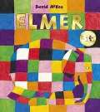  Race | 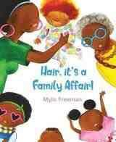  Race | 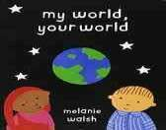  Race | 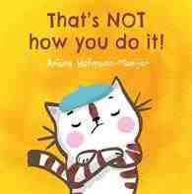  Race | 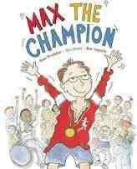  Disability | 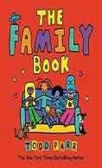  All families are different
 | - Accept who you are  - Proud of my family and our identity |  | - We are all different we all belong in the world  - We do things differently, we can learn from each other |  | - Disability means our bodies work in different ways  - Talk about our families

Year 2 | 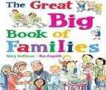  UK is diverse | 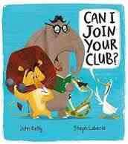  Difference | 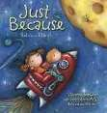  Disability | 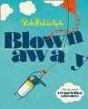  Race | 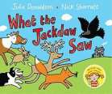  Disability | 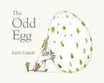  Different families
 | - What does diversity mean?  - I can play with anyone, no one should be left out |  | - Talk about disability and our own needs  - We are all different and we work together in our class |  | - We can adapt to meet others’ needs (sign language)  - What is adoption, what is a family ?

Year 3 | 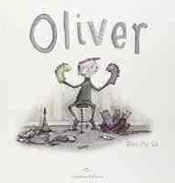 | 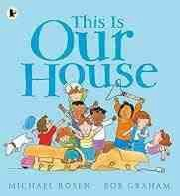 | 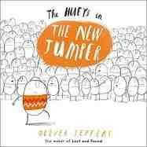 | 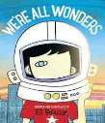 | 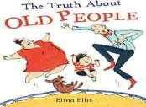 | 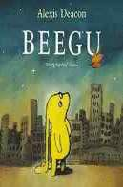
 | - What does diversity mean?  - I can play with anyone, no one should be left out |  | - Talk about disability and our own needs  - We are all different and we work together in our class |  | - We can adapt to meet others’ needs (sign language)  - What is adoption, what is a family

Year 4 | 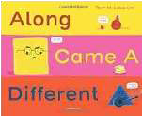 | 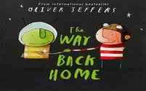 | 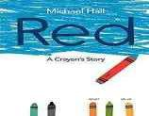 | 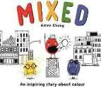 | 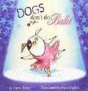 | 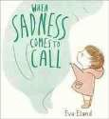
 | - We are all different, it’s great to be different  - People of different race/ culture can work together. Language need not be a barrier |  | - Be true to yourself,  - don’t try to be something you are not  - Why do some people think different races cannot get along? What is the answer to prejudice? |  | - Stand up for your rights, speak out, be true to yourself  - Talk about feelings, recognise sadness, develop strategies to deal with mental health

Year 5 | 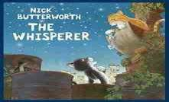 | 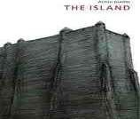 | 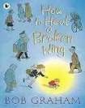 | 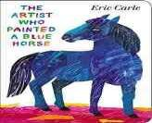 | 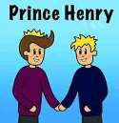
 | - What is peer pressure, how do you stand up against peer pressure?  - Where does racism come from, how can we respond to racist language |  | - What is Amnesty International, why do we help people, what can we do today to help others | - Different people can get married in the UK, laws can change.  - Who were the Nazis in WW2, what did they stand for, what can we do today to make sure ‘never again’?

Year 6 | 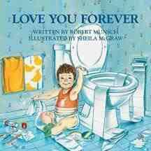 | 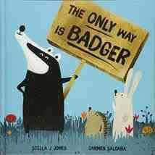 | 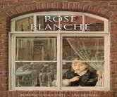 | 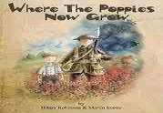 | 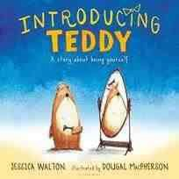 | 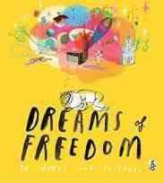
 | - We all grow up, how do our families change, discuss hopes for futu  - How to respond to prejudice, what to do if you witness discrimination? |  | - Historical awareness of Britain in WW2, respect for those who fought for freedom.  - Awareness of holocaust, causes and effect. Recognise what we can do today to make sure ‘never again’ |  | - What does transgender mean, how do we make sure everyone feels welcome  - Identify how people in the UK are different, how do we respond to difference and diversity.

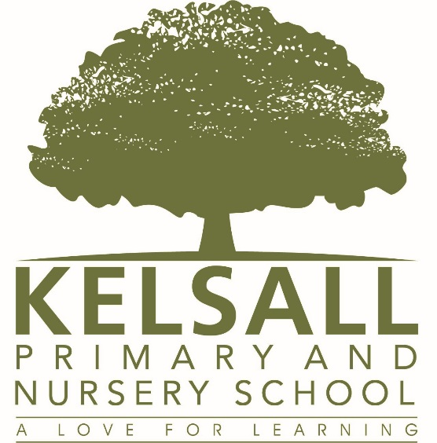

‘All different, All welcome’

